UBER EATS Project
Dashboard Report

Done by Jude felix

1. Project Objective
The objective of this project is to develop a multi-page business intelligence dashboard for Uber Eats using Power BI. The goal is to combine restaurant data from multiple continents, clean and transform the data, create relationships between datasets, and generate meaningful insights that supports data driven decision-making.
The dashboard enables analysis of restaurant performance based on geography, pricing, customer ratings, services offered, and cuisine distribution. It supports drill-down capabilities from continent level to country and city level.

2. Methodology
This section explains the steps followed to prepare, transform, model, and analyze the Uber Eats dataset using Power BI.
2.1 Data Collection
The following datasets were imported into Power BI:
- Africa.xlsx
- Asia.xlsx
- Europe.xlsx
- NAM.xlsx
- SAM.xlsx
- Oceania.xlsx
- Country-Code.xlsx
- Fact Table.xlsx
The continent-level files contained restaurant-level information, while the Fact Table contained performance metrics such as ratings, pricing, and services.

2.2 Data Cleaning (Power Query Editor)
The following transformations were performed:
- Removed unnecessary columns.
- Cleaned inconsistent city names using Trim and Clean functions.
- Checked for null and blank values.
- Verified column data types (numeric, text, decimal).
- Enabled Column Quality, Column Distribution, and Column Profile to validate data consistency.
- Ensured proper formatting of Country Code and Restaurant ID fields.
These steps ensured accurate and reliable data for analysis.

2.3 Data Modeling
A structured data model was created using relationships between tables.
- A One-to-Many relationship was established between Dim_Restaurants and KPIs using Restaurant ID.
- Country Code was linked to the Country Master table.
- A star schema structure was maintained to improve performance and filtering behavior.
- Proper cross-filter direction was applied to ensure drill-down functionality.
The model enables filtering across Continent → Country → City → Restaurant levels.

3. DAX Measures and Implementation Logic
To support interactive dashboard analysis, multiple DAX measures were created.

3.1 Cost and Rating Measures
Avg Cost =
AVERAGE(KPIs[Average Cost for Two])
This measure calculates the average cost for two people.
Avg Rating =
AVERAGE(KPIs[Aggregate rating])
This measure calculates the average customer rating.

3.2 Ranking Measures
Rank by Cost =
RANKX(
ALL(Dim_Restaurants[Restaurant ID]),
[Avg Cost],
,
ASC,
DENSE
)
Ranks restaurants by lowest cost.
Rank by Rating =
RANKX(
ALLSELECTED(Dim_Restaurants[Restaurant ID]),
[Avg Rating],
,
DESC,
DENSE
)
Ranks restaurants by highest rating.

3.3 KPI Indicator Measures
Total Restaurants Icon =
"🍴 " & FORMAT(DISTINCTCOUNT(Dim_Restaurants[Restaurant ID]), "#,0")
Displays total restaurant count.
Avg Cost Icon =
"💰 ₹ " & FORMAT(AVERAGE(KPIs[Average Cost for Two]), "#,0")
Displays formatted average cost.
Total Cities Icon =
"🏙 " & FORMAT(DISTINCTCOUNT(Dim_Restaurants[City]), "0")
Displays total number of cities.
Total Countries Icon =
"🌍 " & FORMAT(DISTINCTCOUNT('Country Master'[Country Code]), "0")
Displays total number of countries.

3.4 Rating Classification Logic
Rating Group =
SWITCH(
TRUE(),
KPIs[Aggregate rating] >= 4, 5,
KPIs[Aggregate rating] >= 3, 4,
KPIs[Aggregate rating] >= 2, 3,
KPIs[Aggregate rating] >= 1, 2,
1
)
Groups ratings into performance levels.
Rating Range =
SWITCH(
TRUE(),
KPIs[Aggregate rating] >= 4.5, "4.5 - 5.0",
KPIs[Aggregate rating] >= 4.0, "4.0 - 4.5",
KPIs[Aggregate rating] >= 3.5, "3.5 - 4.0",
KPIs[Aggregate rating] >= 3.0, "3.0 - 3.5",
KPIs[Aggregate rating] >= 2.5, "2.5 - 3.0",
"< 2.5"
)
Categorizes ratings into defined slabs.
RatingColorHex =
SWITCH(
KPIs[Rating Group],
1, "#D7191C",
2, "#F07C00",
3, "#FFD700",
4, "#66BD63",
5, "#1A9641",
"#CCCCCC"
)
Assigns color codes for conditional formatting

4.1 Page 1 – Global Overview
Page 1 presents a global summary of restaurant performance across continents, countries, and cities. The report includes key KPIs such as total restaurants, total cities, total countries, average rating, and average cost for two. Users can drill down from continent level to country and city level for detailed analysis.
A rating-based button slicer is implemented using the defined rating groups and color logic. This allows users to filter restaurants from rating level 1 to 5, with each level visually represented using conditional color formatting. This feature helps quickly identify high-performing and underperforming regions based on customer satisfaction.
The page also includes filtering based on online delivery and table booking availability. This enables analysis of service coverage across different locations and helps identify areas where delivery services are more active or less developed.

Page 1 – Key Insights
- Philippines has the highest average rating (4.47).
- India has the lowest average rating (2.52) and needs improvement.
- Inner City is the top-performing city with a 4.90 rating.
- Indonesia has the highest average cost for two.
- Australia and the United States show lower average pricing.
- Online delivery availability is higher in India compared to UAE

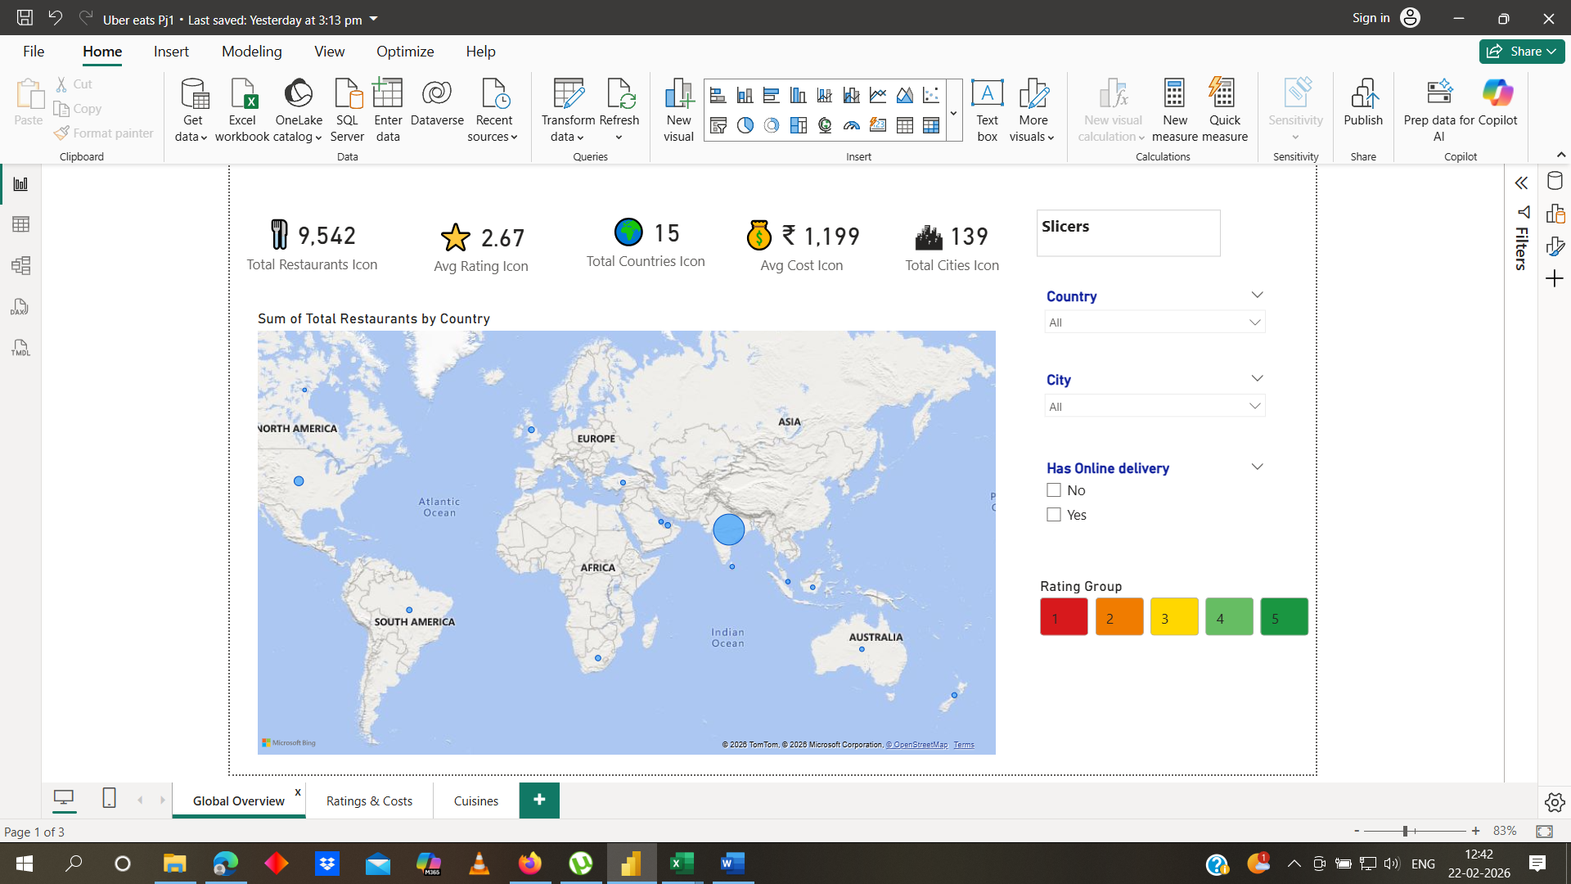

4.2 Page 2 – Rating and Cost Performance
Page 2 displays the Top 10 highest-rated restaurants using the Average Rating measure, along with cards showing the selected country and city for context. It also includes a table highlighting restaurants with the lowest average cost to compare affordability across regions.
High-rated restaurants are concentrated in specific cities, while low-cost restaurants are spread across different regions, showing variation between customer satisfaction and pricing.

Page 2 – Key Insights
- Top-rated restaurants are concentrated in countries like the Philippines and Turkey.
- Lower-cost restaurants are more common in Australia and the United States.
- Clear variation exists between pricing and rating performance across regions.

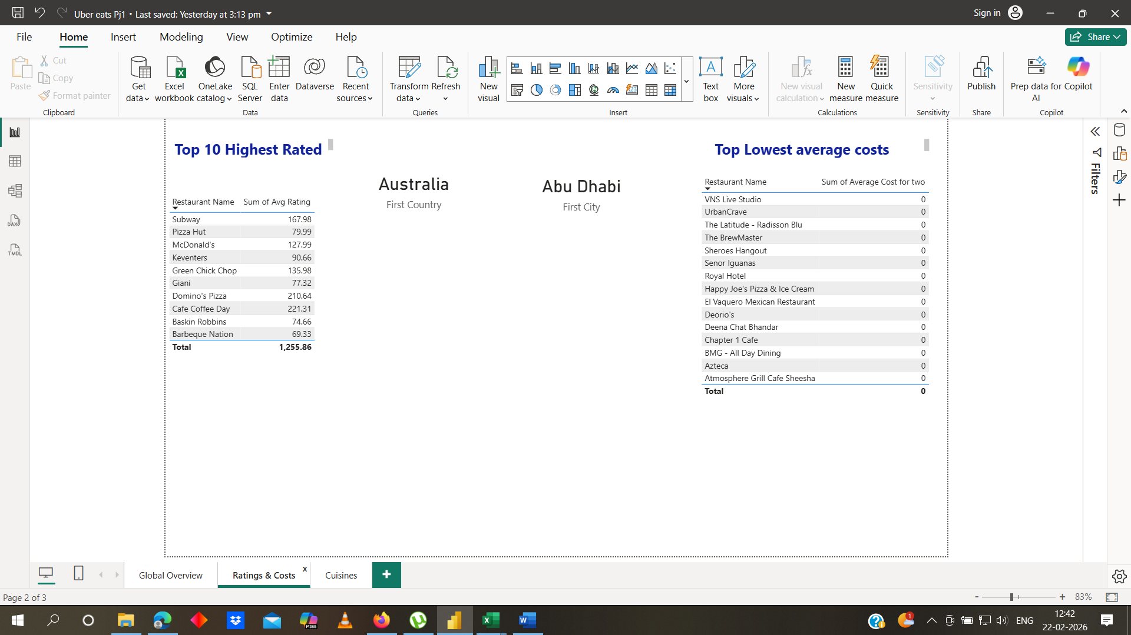

4.3 Page 3 – Cuisine Distribution Analysis

Page 3 uses a stacked bar chart to identify restaurants serving the highest number of cuisines. This visualization highlights restaurants with diversified menu offerings and allows comparison across locations.
Key Insight: Restaurants offering a wider variety of cuisines tend to stand out in specific regions, indicating higher menu diversity in competitive markets
Page 3 – Key Insights
- Cafe Coffee Day, Dominos, and Subway serve the highest number of cuisines.
- Restaurants with more cuisine variety tend to have stronger market presence.

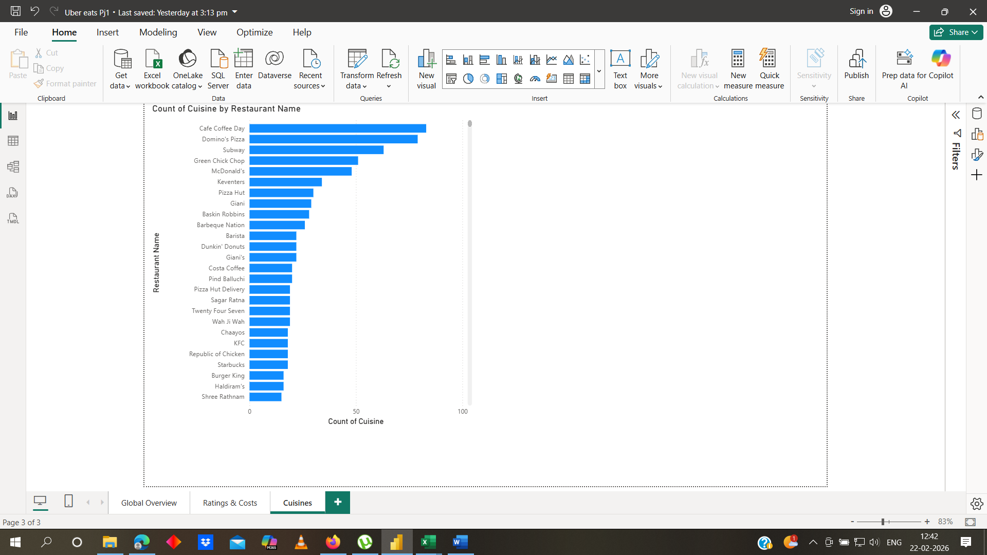

5. Model View Explanation
- The data model connects fact and dimension tables using Restaurant ID and Country Code.
- Dimension tables such as Countries and Restaurants improve filtering and aggregation.
- Relationships enable accurate calculation of average rating, cost, and restaurant count.
- The structured model supports drill-down from country to city level.

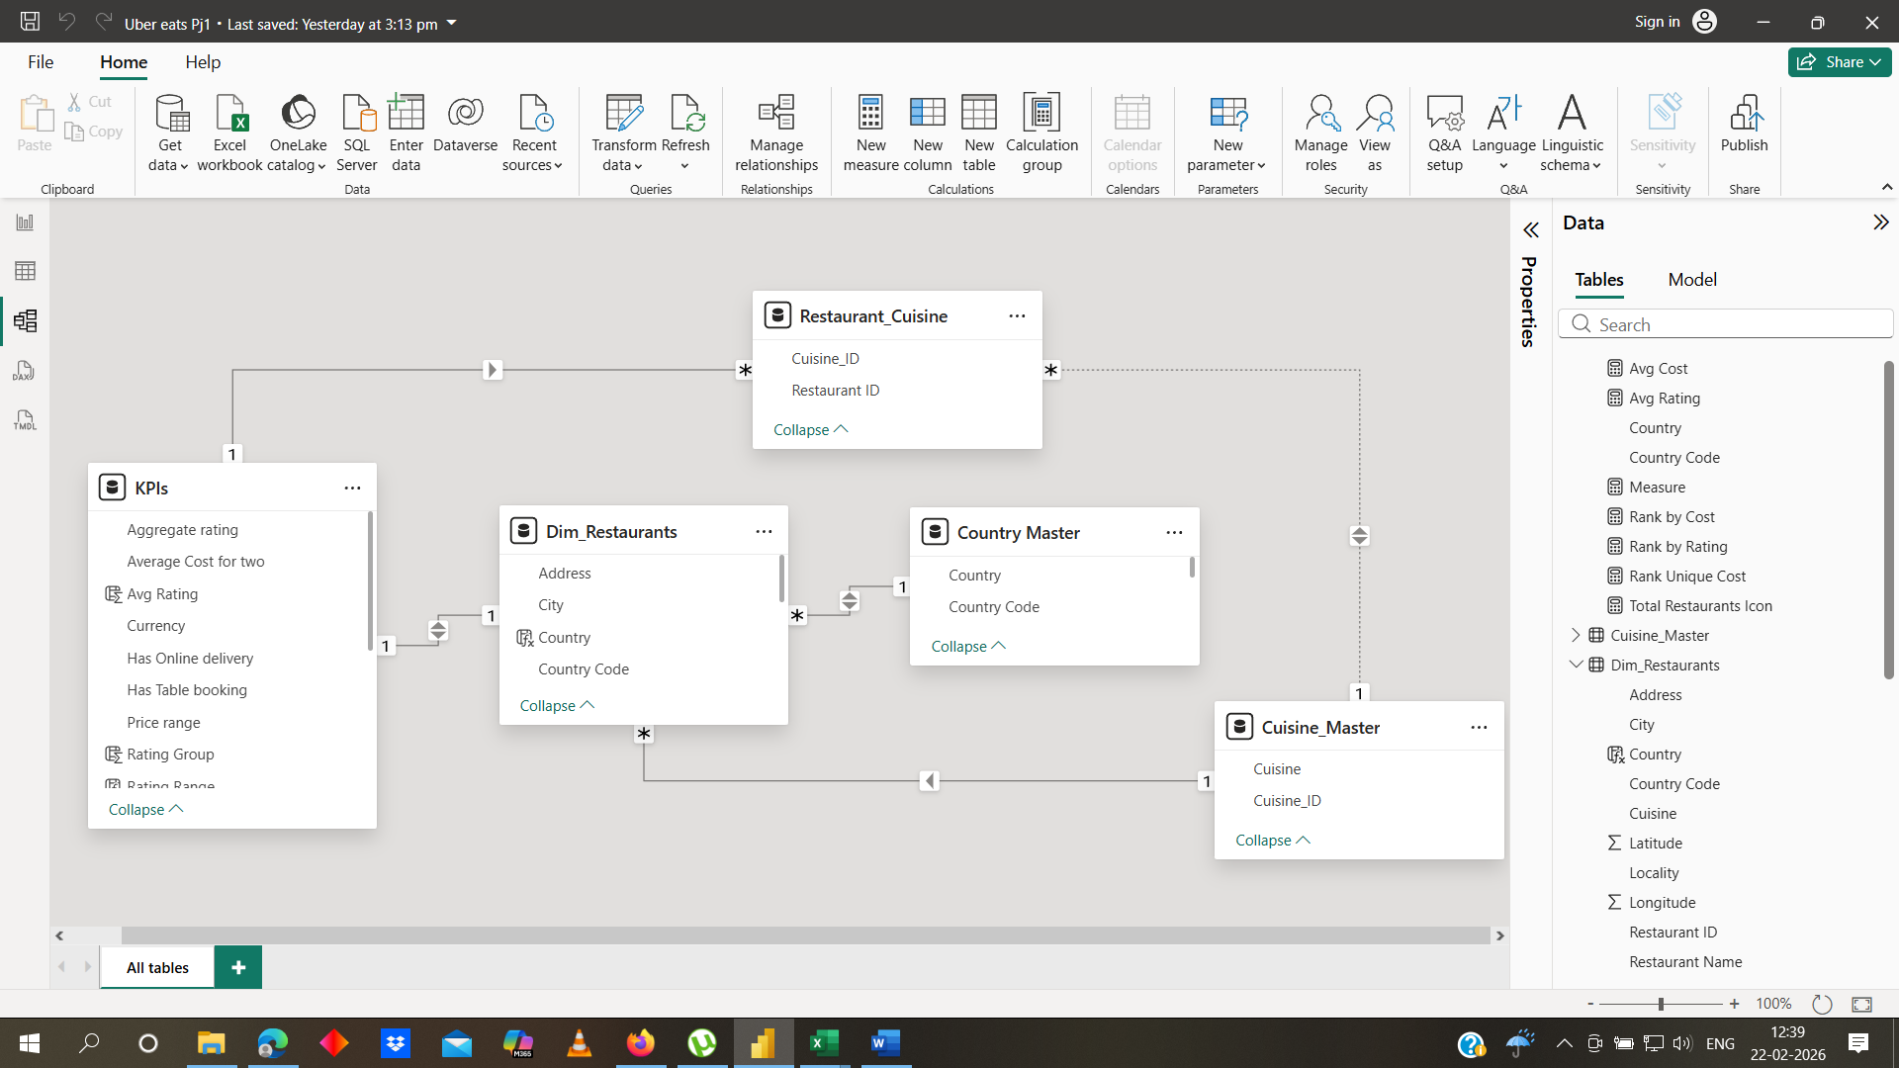
6. AI Insights (Power Query Analysis)
- Column Quality was enabled to check valid, error, and empty values.
- Column Distribution was used to understand value spread and detect outliers.
- Column Profile helped analyze minimum, maximum, and distinct values.
- Data validation ensured clean and consistent data before modeling

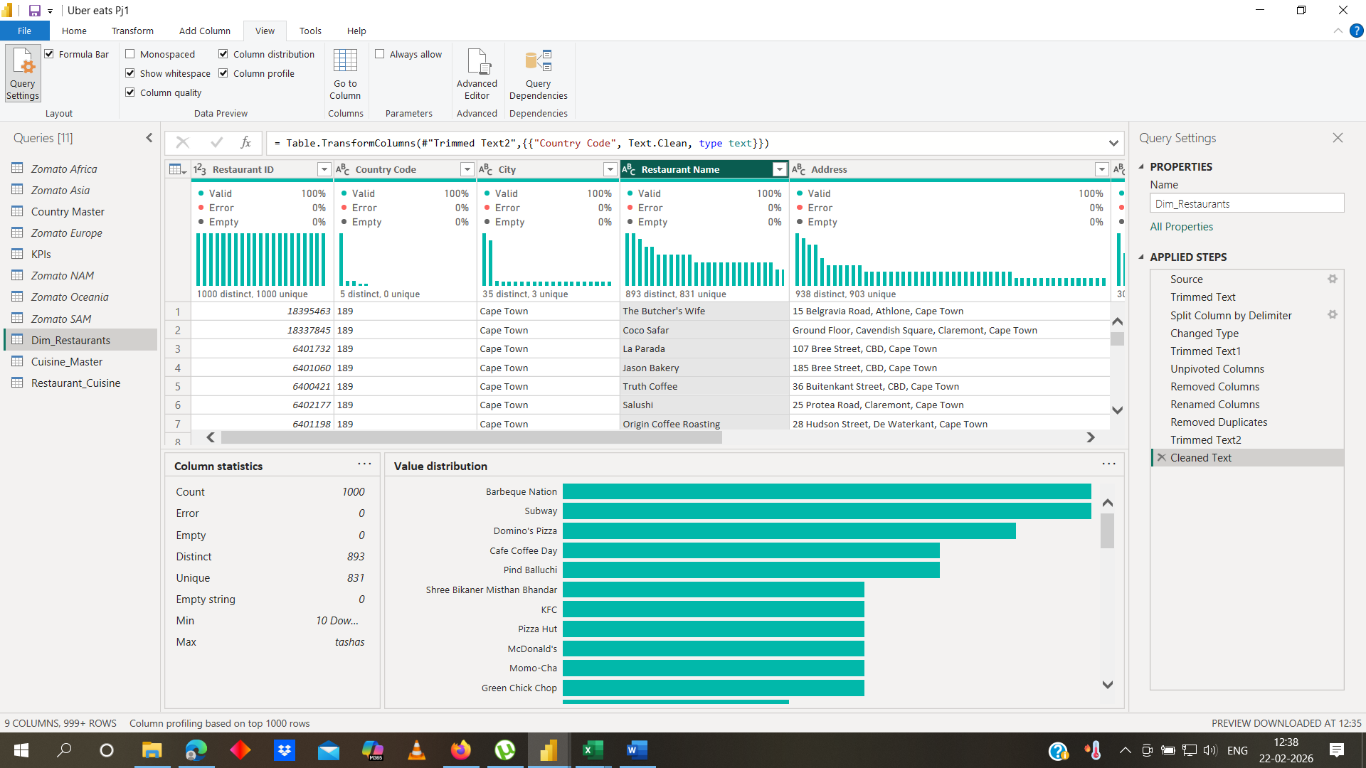
AI insights screen

